Workshop: Petstagram
We will be creating a complete Django project called "Petstagram" throughout this module. The project will cover the following functionalities: user registration, login, and logout; each user can add pets to their profile and upload pet photos; a user can view all photos of pets, open details, where can like and comment on a photo. Each user can edit and delete their photos and pet information.
The full project description can be found in the Workshop Description Document.

Workshop - Part 1.1

Setup
Let us start by creating the project:
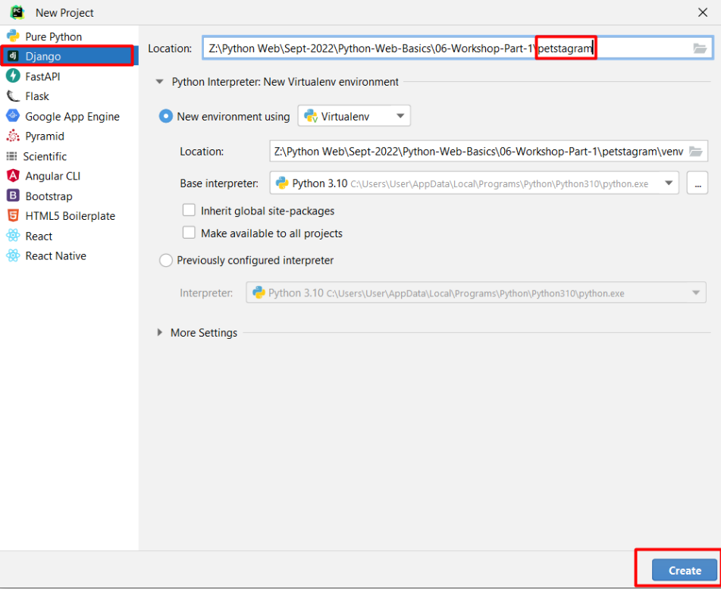
To check if everything works correctly, we can start the development server. One way to do it is to use the PyCharm Toolbar:
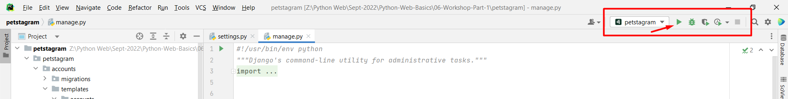
Another way to do this is to write the command python manage.py runserver in the Terminal and click on the provided link:
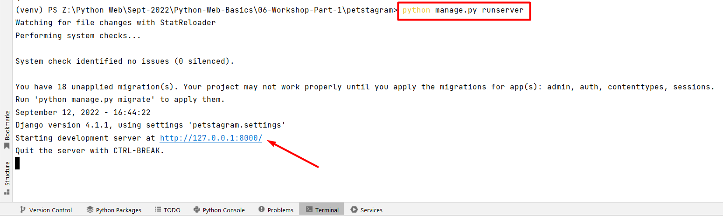
You should see the autogenerated Django "Congratulations" page: 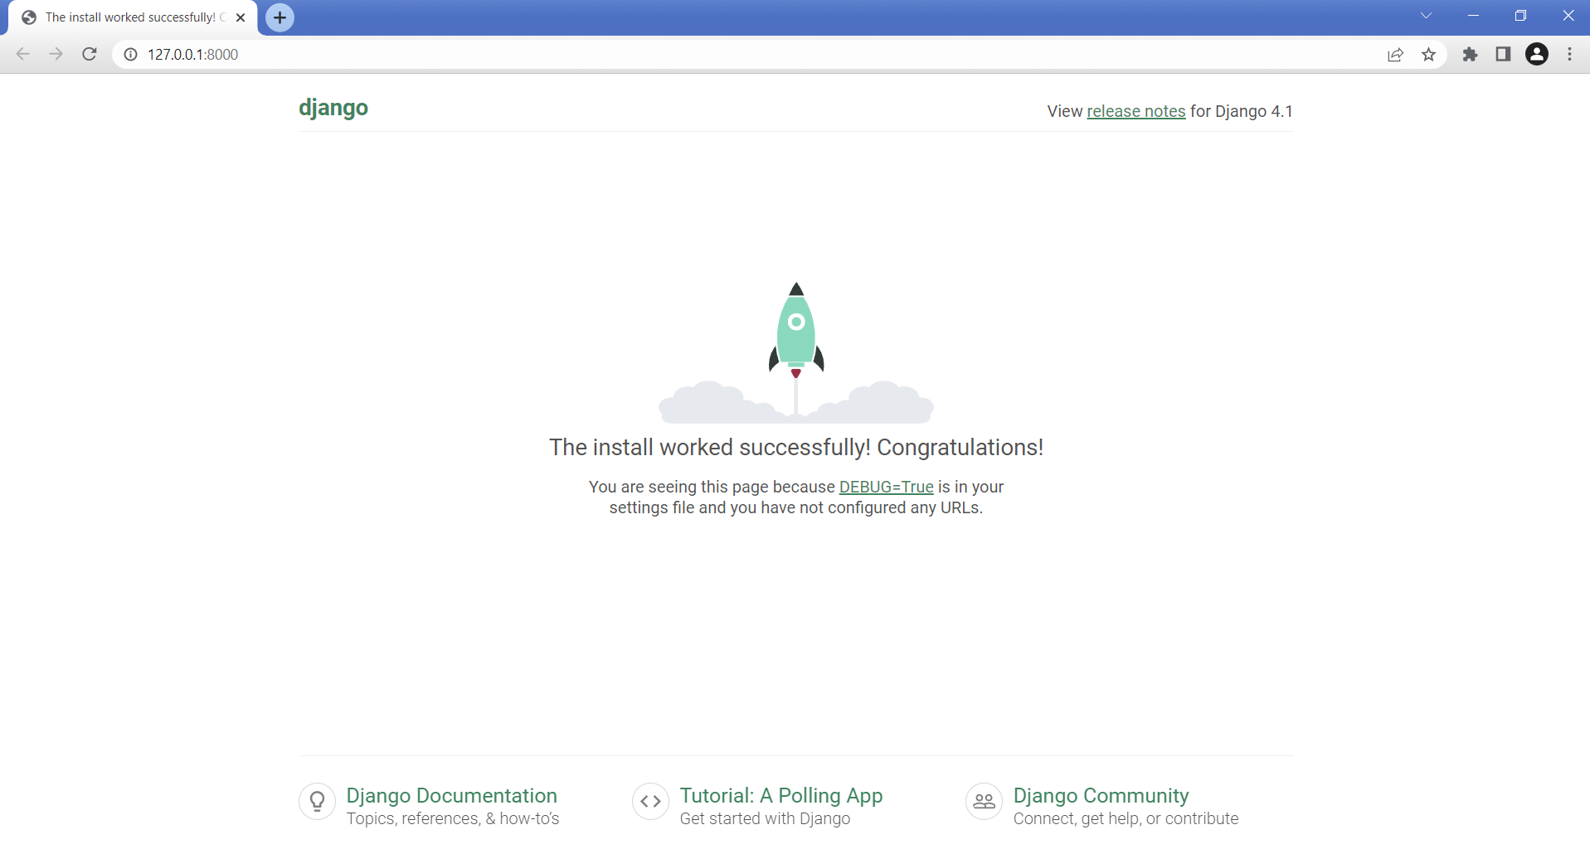

Creating the Apps
Now, let us create the apps we will work with. They are called 'photos', 'pets', 'accounts', and 'common' and they will contain all parts of our project:
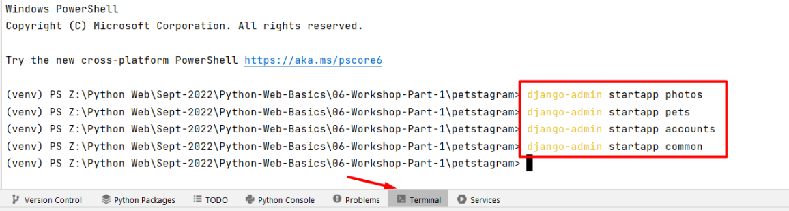

For clarification, move the created apps inside the project:
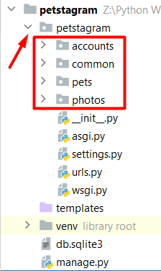

Configurations
We need to add the apps we just created in the INSTALLED_APPS setting:
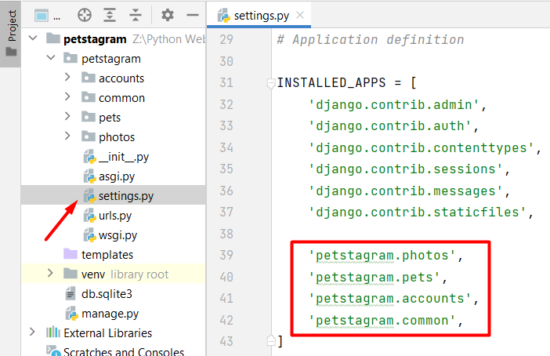

Workshop - Part 1.2

Adding the Templates
The next step is to create the templates folder inside each app directory and add the given templates to it. The templates associated with the account should be added to the accounts app:
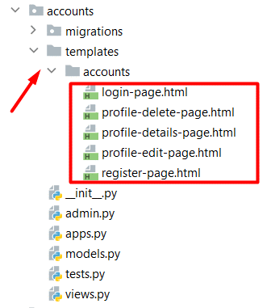
Respectively, the templates associated with the photos should be placed into the photos app:
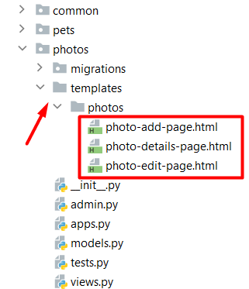
The templates associated with the pets should be placed into the pets app:
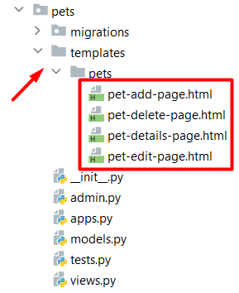
We can position the home-page template in the common app:
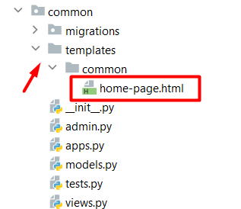
The only template left is the 404.html. By default, it should be put inside the project templates directory on the manage.py level:
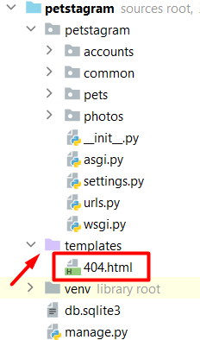

Adding the Static Files
Add a directory called static on the manage.py level:
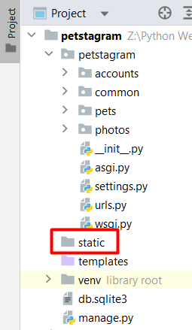
Add the provided folders ("css" and "images") to the directory. Next, Django should find the static files when loading web pages, so write the setting in the settings.py file: 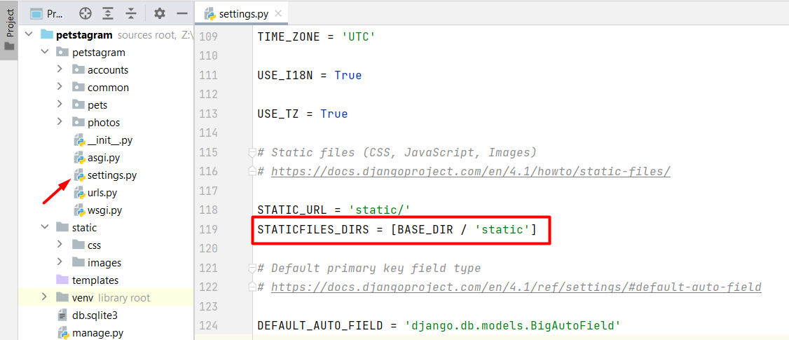

Adding the URLs (paths)
We want to load each template in the browser using a concrete path - each app should load its templates.
To do that, we should add urls.py files in each app:
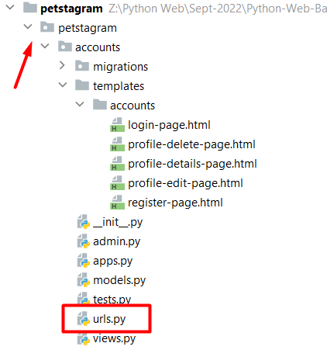
Then, we can start including them in the main project urls.py file. We should import the include() function from the Django urls module, then we can use the path() function to construct a path, which will lead to each app urlpatterns:
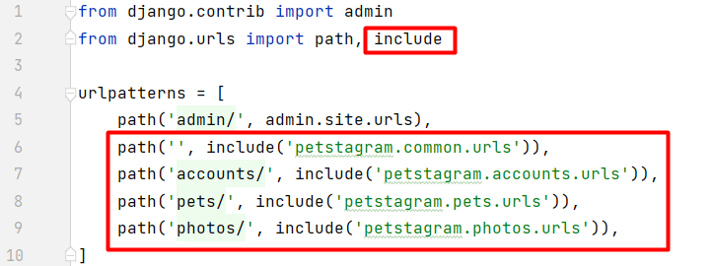
Next, in each app create an urls.py file. Then, create paths connected to each view we will configure. Let us start by adding the following paths in the accounts app:
Registration Page: http://127.0.0.1:8000/accounts/register/
Login Page: http://127.0.0.1:8000/accounts/login/
Profile Details Page: http://127.0.0.1:8000/accounts/profile/<int:pk>/
Profile Edit Page: http://127.0.0.1:8000/accounts/profile/<int:pk>/edit/
Profile Delete Page: http://127.0.0.1:8000/accounts/profile/<int:pk>/delete/
In order to do that, we should create a urlspatterns list in the accounts/urls.py file: 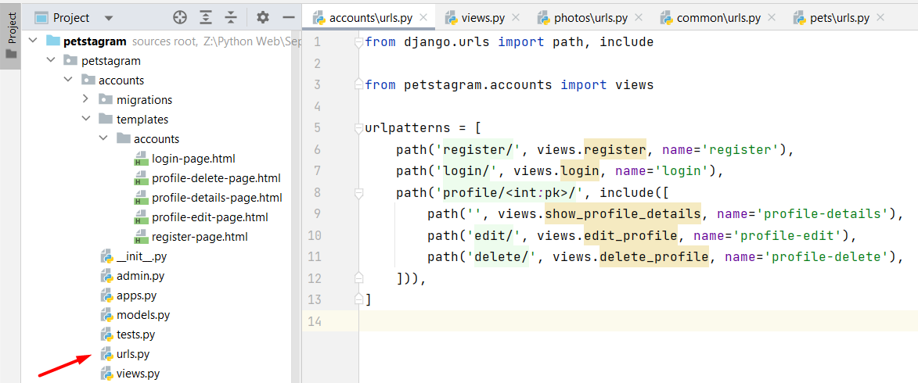
The same configuration should be added to the other apps for the following URLs:
Home Page: http://127.0.0.1:8000/
Photo Add Page: http://127.0.0.1:8000/photos/add/
Photo Details Page: http://127.0.0.1:8000/photos/<int:pk>/
Photo Edit Page: http://127.0.0.1:8000/photos/<int:pk>/edit/
Pet Add Page: http://127.0.0.1:8000/pets/add/
Pet Details Page: http://127.0.0.1:8000/pets/<str:username>/pet/<slug:pet_name>/
Pet Edit Page: http://127.0.0.1:8000/pets/<str:username>/pet/<slug:pet_name>/edit/
Pet Delete Page: http://127.0.0.1:8000/pets/<str:username>/pet/<slug:pet_name>/delete/

Adding Views
As you see, we have not created the views so far, and they appear to be missing in the urls.py file. Now, we will start adding them to the views.py file for each app. For example, we will use the names of the views created in the accounts/urls.py file to create the views in the accounts/views.py file: 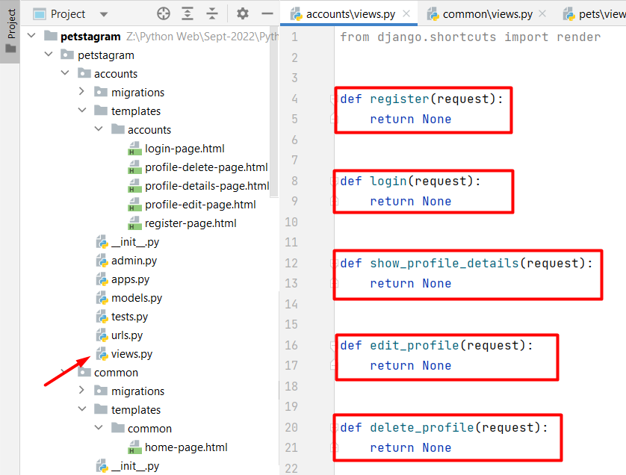
Each view should receive a request and return a response. The response we want to return is a rendered HTML page we already added to our templates/accounts directory. Let us write a render function for each view to return: 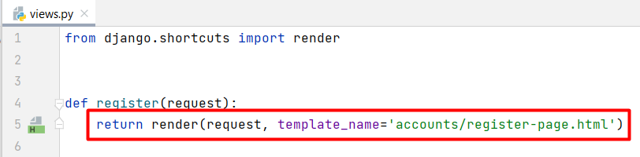
The first parameter the render() function accepts is the given request. Next, we could pass the template we want to be shown when loading the specific path. In this case, when we load http://127.0.0.1:8000/accounts/register/ we should see the register-page template: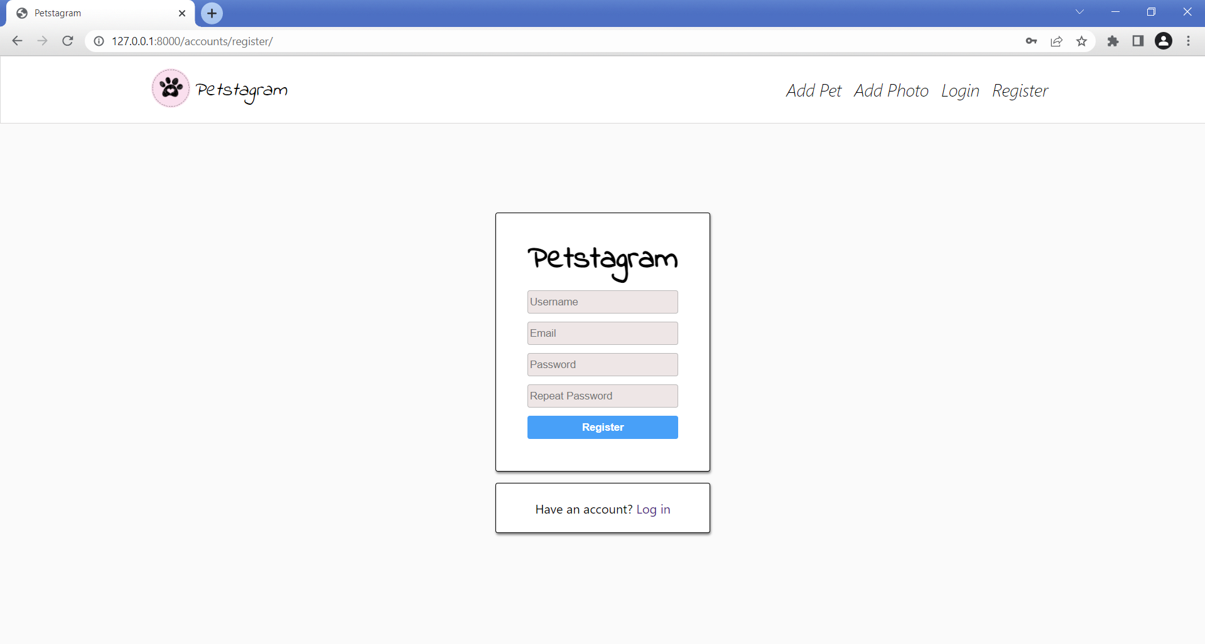
In the same way we can create all views in the project.

Workshop - Part 1.3

Creating Template Inheritance
If we look closely at each template, we can see that there are many common parts. The head, the header with the navigation bar, and the footer are the same for all templates. We can export them in a separate .html file in the project's template directory.
Let us create a base.html template in the templates directory on the manage.py level. We will position it there because the code is common for all apps:
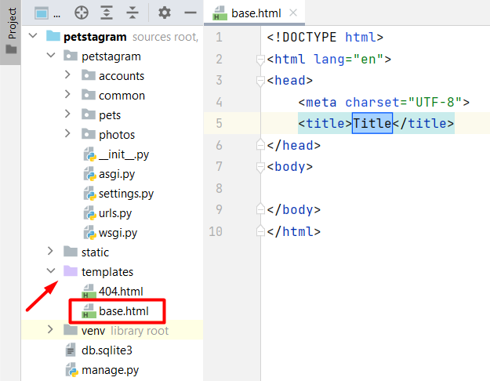
Now, we can add all common parts that will structure the base template:
<!DOCTYPE html>
<html lang="en">
<!-- Starts Head Section -->
<head>
<link rel="stylesheet"
href="/static/css/styles.css">
<link rel="icon" type="image/x-icon" href="/static/images/free-30-instagram-stories-icons23_122570.png">
<title>Petstagram</title>
</head>
<!-- End Head Section -->
<!-- Starts Body Section -->
<body>
<!-- Starts Header Section with Navigation Bar -->
<header>
<nav class="navbar">
<div class="container">
<div class="logo">
<!-- Link to Home Page -->
<a href="#"><img width="50px" src="/static/images/free-30-instagram-stories-icons23_122570.png" alt="img1"></a>
<!-- Link to Home Page -->
<a class="home" href="#"><i>Petstagram</i></a>
</div>
<div class="nav-links">
<ul class="nav-group">
<li class="nav-item">
<!-- Link to Add Pet Page -->
<a href="#"><i>Add Pet</i></a>
</li>
<li class="nav-item">
<!-- Link to Add Photo Page -->
<a href="#"><i>Add Photo</i></a>
</li>
<li class="nav-item">
<!-- Link to Login Page -->
<a href="#"><i>Login</i></a>
</li>
<li class="nav-item">
<!-- Link to Register Page -->
<a href="#"><i>Register</i></a>
</li>
<li class="nav-item">
<!-- Link to Profile Page -->
<a href="#"><i>Profile</i></a>
</li>
</ul>
</div>
</div>
</nav>
</header>
<!-- End Header Section with Navigation Bar -->
<!-- Starts Main Section -->
<main>
</main>
<!-- End Main Section -->
...

...
<!-- Start Footer Section -->
<div class="footer">
<span class="footer-section">© 2022 SOFTUNI WORKSHOP FOR PYTHON WEB MODULE</span>
</div>
<!-- End Footer Section -->
</body>
</html>

Next, we should connect the base template with all the other templates. In the base template mark the place where the code should be extended - it is only the main part:
<!DOCTYPE html>
<html lang="en">
...
<!-- Starts Main Section -->
<main>
{% block content %}
{% endblock %}
</main>
<!-- End Main Section -->
...
</html>
We should delete the common part of each template and add the appropriate tags. For example, the register-page template should look like this:
{% extends 'base.html' %}
{% block content %}

<!-- Start Register Section-->
<div class="login-register-div">
<div class="login-register-box">
<h1>Petstagram</h1>

<!-- Start Register Form-->
<form action="">
<input type="text" placeholder="Username"><br>
<input type="email" placeholder="Email"><br>
<input type="password" placeholder="Password"><br>
<input type="password" placeholder="Repeat Password"><br>

<!-- Register Button-->
<button type="submit">Register</button>
</form>
<!-- End Register Form -->
</div>
<div class="second-option"><p>Have an account?

<!-- Link to Login Page-->
<a href="#">Log in</a></p>
</div>
</div>
<!-- End Register Section-->
{% endblock %}
If you start the development server and load the register page, you should see no difference between the style of the page now and the one before: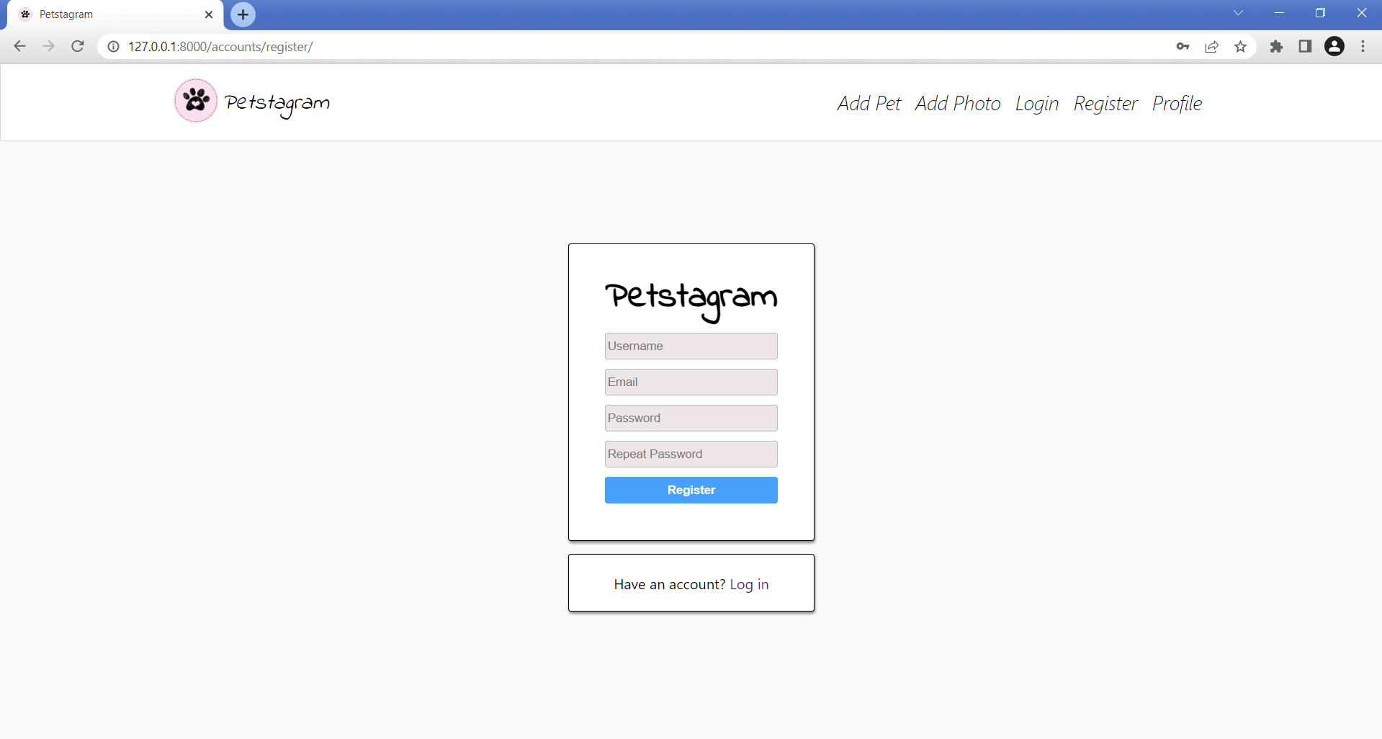

Separating Common Parts
We can see that there are common parts for couple of pages. Let us start by checking the templates home-page.html and pet-details-page.html - both templates have pet photos (posts) part: 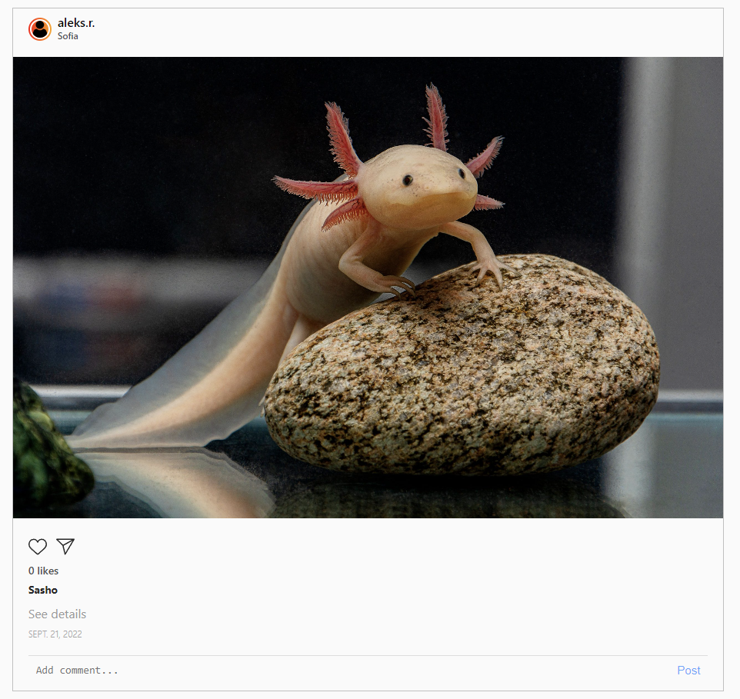
We can move it to separate template and then include the template in home-page.html and pet-details-page.html. So, let us create a new template called pets-photos.html in the common app: 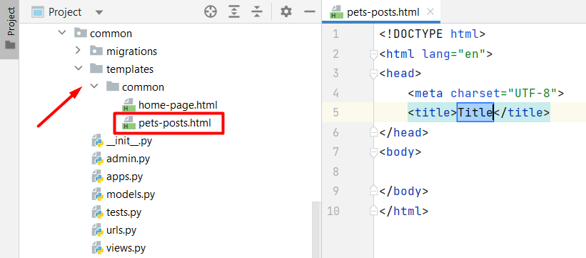
Then, move all the posts with photos to the pets-posts.html and include the template using the include template tag in the home-page.html:
{% extends 'base.html' %}
<!-- Main Code -->
{% block content %}
<div class="container">
<div class="col-9">
<!-- Searchbar -->
<form class="searchbar" method="post">
<input type="text" placeholder="Search by pet name...">
<button>
<img src="/static/images/search.png" height="18" alt="img2">
</button>
</form>
{% include 'common/pets-posts.html' %}
</div>
</div>
{% endblock %}
Next, delete the pets' photos in the pet-details-page.html template and include the pets-post.html template:
{% extends 'base.html' %}
{% block content %}
<div class="pet-profile">
<div class="profile">
<div class="profile-data">
<div class="profile_img">
<div class="image">
<img src="https://encrypted-tbn0.gstatic.com/images?q=tbn:ANd9GcTgoIHq82qLYnvomfz5ZkW5CLQ8VNxCyI-hUw&usqp=CAU"
alt="img8">
</div>
</div>
<div class="personal">
<div class="edit">
<p>Sasho</p>
<a href="">
<img class="edit-img" src="/static/images/edit-pen-icon-6.jpg" alt="edit button">
</a>
<a href="">
<img class="bin-img" src="/static/images/icon-remove-22.jpg" alt="bin button">
</a>
</div>
<div class="data">
<span>4</span>
<p>photos</p>
</div>
</div>
</div>
</div>
<div class="pet-posts">
<!-- Start if pet photos -->
{% include 'common/pets-posts.html' %}
<!-- End if pet photos -->
<!-- Start if not pet photos -->
<img class="no-posts" src="/static/images/no_posts.png" alt="no posts image">
<!-- End if not pet photos -->
</div>
</div>
{% endblock %}

One more thing - you see that there are 3 posts with pet pictures, so we can delete two of them and leave just one that we will work with in the next sessions. Hint: it is easy to see the blocks of code when we collapse the code sections: 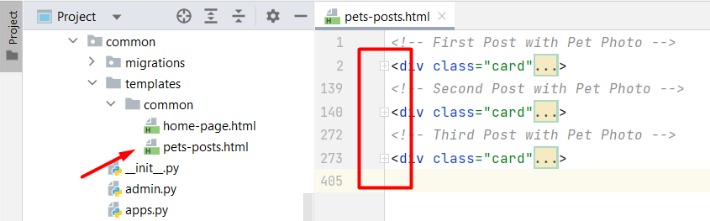

Workshop - Part 1.4

Adding Static Files in Templates
Django uses special template tag to tell the template engine to use the files from the static folder. In each template where we will use static files this tag should be added. In the base template it will look like this:
{% load static %}
<!DOCTYPE html>
<html lang="en">
<!-- Head -->
<head>
<link rel="stylesheet" href="{% static 'css/styles.css' %}">
<link rel="icon" type="image/x-icon" href="{% static 'images/free-30-instagram-stories-icons23_122570.png' %}">
<title>Petstagram</title>
</head>
<!-- Body -->
<body>
<!-- Header -->
<header>
<nav class="navbar">
<div class="container">
<div class="logo">
<a href="#"><img width="50px" src="{% static 'images/free-30-instagram-stories-icons23_122570.png' %}" alt="img1"></a>

...

Adding Hyperlinks in Templates
In the base template is positioned the navigation bar. It navigates the users to different parts of our app. To be fully functional, hyperlinks should be added to it. Using Django Template Language, it is not a difficult task to be done. We will use the url template tag and map it to the view names that we wrote in the urlpatterns list: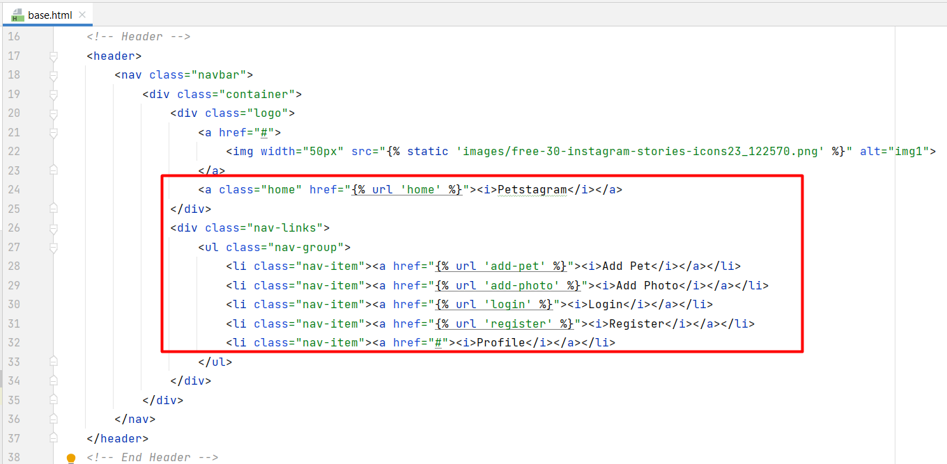
For now, we CANNOT add the profile hyperlink implementation. We will handle it in the next Web course.
A thing we could do is to "handle" it by adding a number for the "pk" parameter. Any number will work, as there is no implementation for user so far (Note: remember to change it in the future):

404 Template
When we implement the inheritance and load the static files in the template, it should look like this: 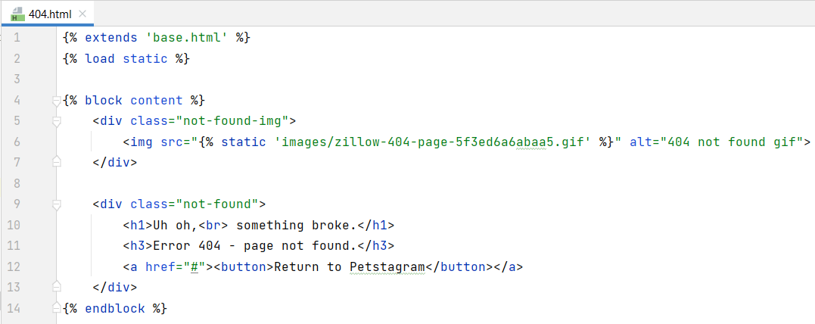
The only thing needed to be done here is adding a hyperlink which will lead to the Petstagram home page. We can use the url tag:
The page is only visible when DEBUG setting is set to False. Let us use "*" syntax to allow all hosts to reach the app:
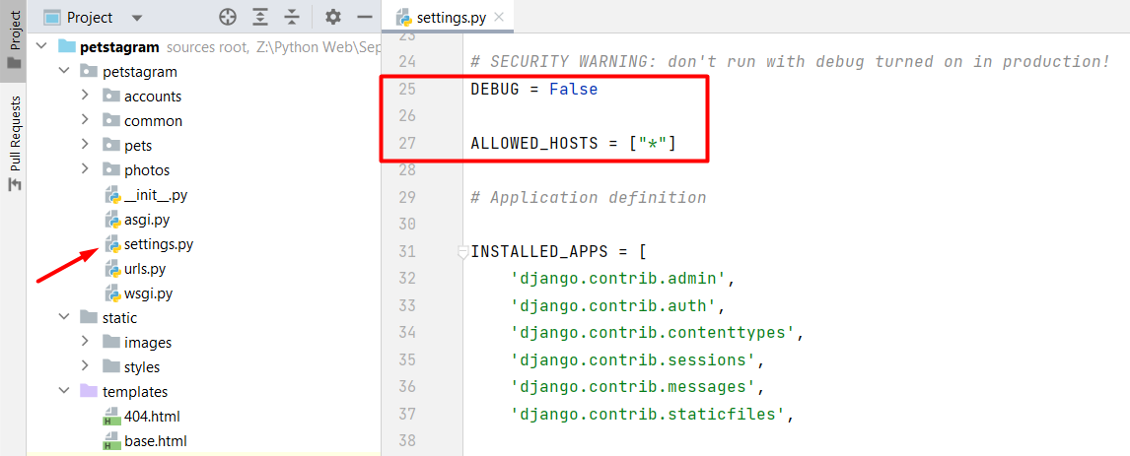
When you start the development server and try to reach an invalid page you should see the 404 Template:
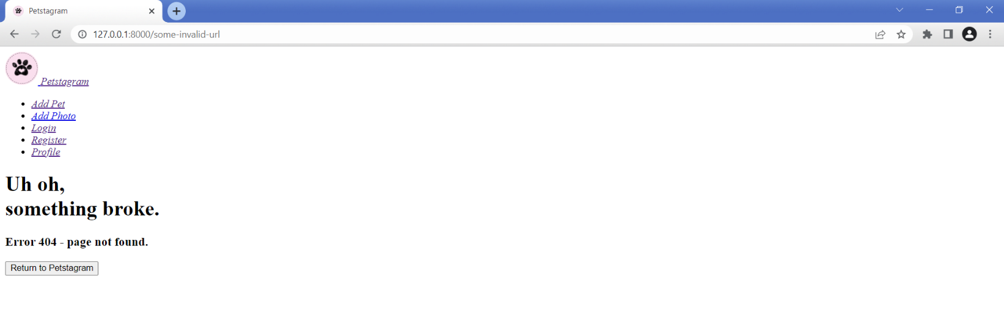
Notice that the HTML is loaded, but the CSS is NOT loaded. With debug turned off Django will not handle static files for us. The meaning of DEBUG set to False is that the app is in production, so the production web server should take care of the style. To test in DEBUG False mode locally, we can run the development server with a specific command: "python manage.py runserver --insecure":